EXPERIMENT 15 PPS: Car dealership sales system
A] ALGORITHM:
Step 1: Start
Step 2: Define a base class Car
- Declare attributes: brand, price, model, color
Step 3: Define constructor __init__()
- Initialize all attributes using input values
Step 4: Define method display_details()
- Print brand, price, model, and color (each on separate line)
Step 5: Define derived class Car1
- Inherit from class Car
- Override method display_details() to print details
Step 6: Define derived class Car2
- Inherit from class Car
- Override method display_details() to print details
Step 7: Read input for first car
- Store values: brand1, price1, model1, color1
Step 8: Read input for second car
- Store values: brand2, price2, model2, color2
Step 9: Create object car1 of class Car1
- Pass first car details
Step 10: Create object car2 of class Car2
- Pass second car details
Step 11: Call display_details() for car1
- Print first car details
Step 12: Call display_details() for car2
- Print second car details
Step 13: Stop
B]FLOWCHART:
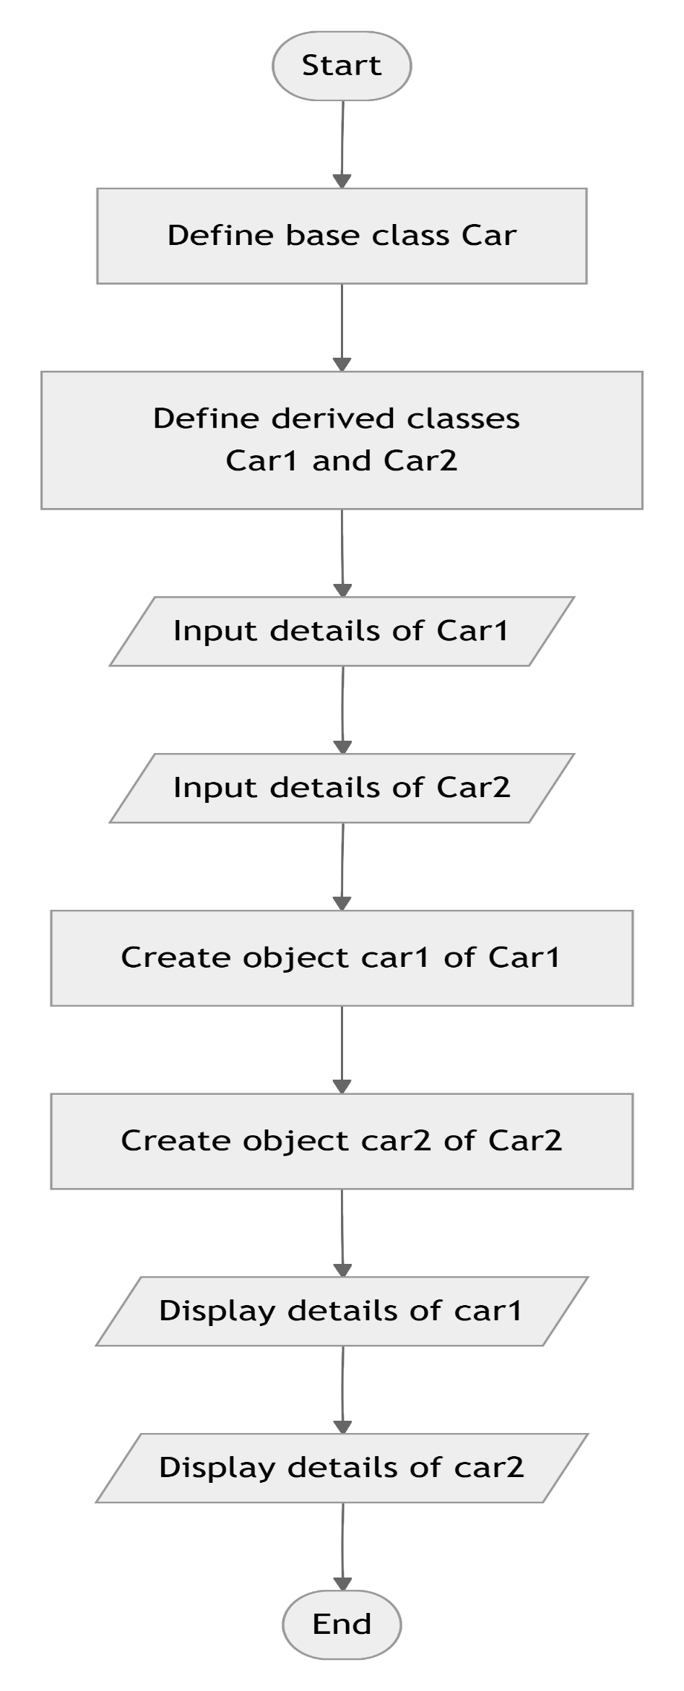

C]CODETANTRA:

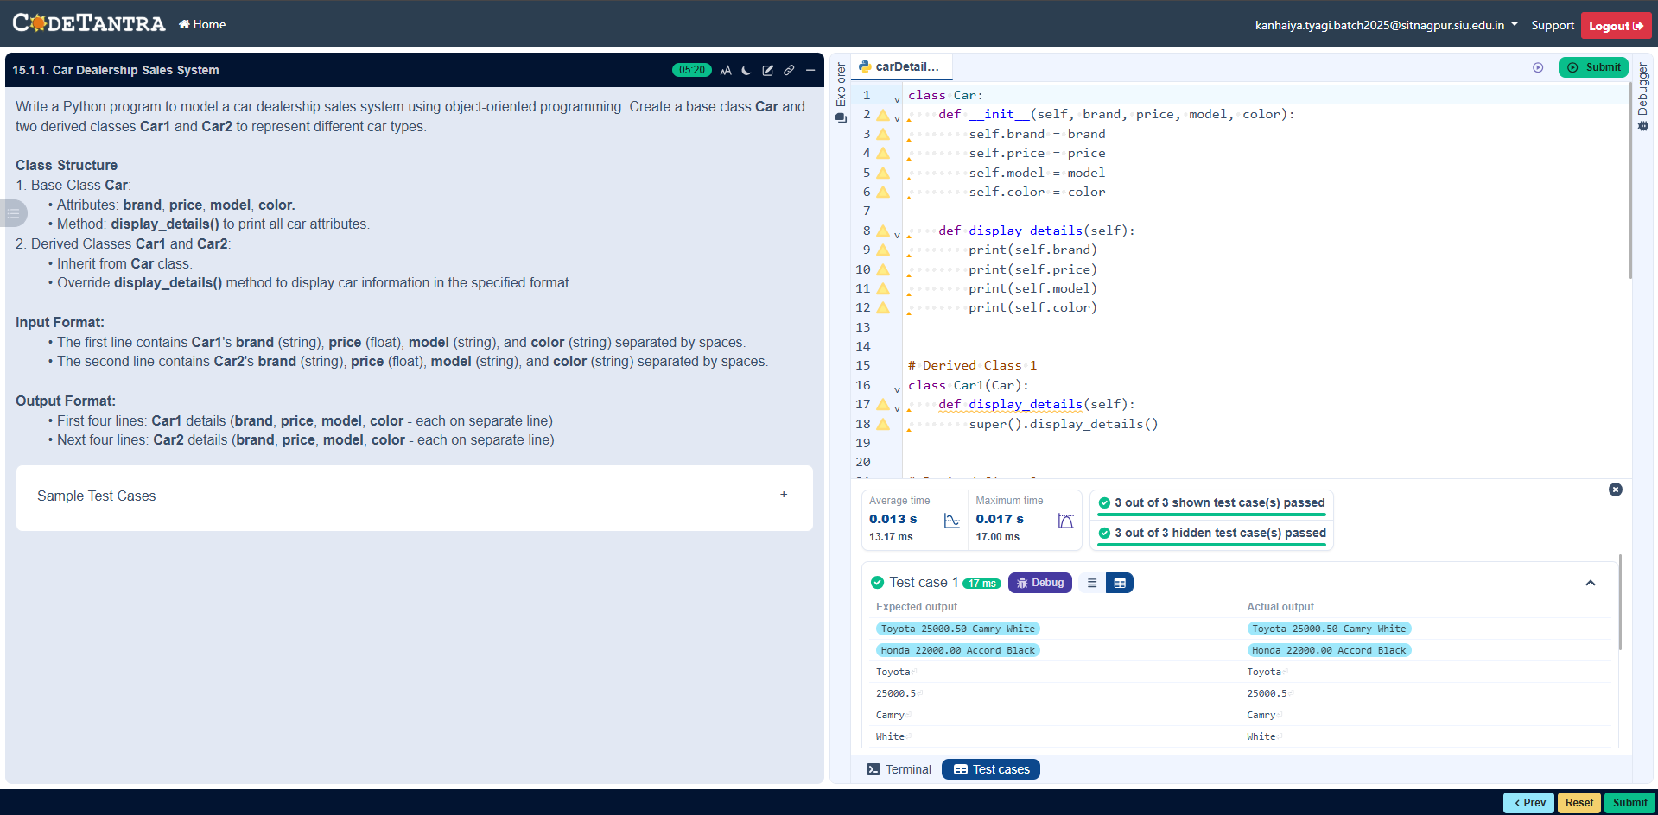
D] code:
class Car:
def __init__(self, brand, price, model, color):
self.brand = brand
self.price = price
self.model = model
self.color = color

def display_details(self):
print(self.brand)
print(self.price)
print(self.model)
print(self.color)

# Derived Class 1
class Car1(Car):
def display_details(self):
super().display_details()

# Derived Class 2
class Car2(Car):
def display_details(self):
super().display_details()

# Read input
car1_data = input().split()
brand1, price1, model1, color1 = car1_data[0], float(car1_data[1]), car1_data[2], car1_data[3]

car2_data = input().split()
brand2, price2, model2, color2 = car2_data[0], float(car2_data[1]), car2_data[2], car2_data[3]

# Create objects
car1 = Car1(brand1, price1, model1, color1)
car2 = Car2(brand2, price2, model2, color2)

# Display details
car1.display_details()
car2.display_details()

